necklaces |  |  |  |  |  |  |  |  | total
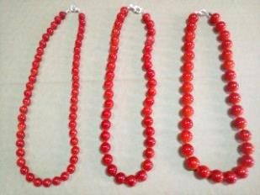 |  |  |  |  |  |  | pieces | price € | amount
 |  |  | pearl | 8mm. | 10 mm. | 12 mm.
 |  |  | red | 110 pcs. | 300 pcs. | 210 pcs.
 |  |  | blue | 150 pcs. | 390 pcs. | 250 pcs.
 |  |  | purple | 170 pcs. | 370 pcs. | 210 pcs.
 |  |  | green | 170 pcs. | 370 pcs. | 340 pcs.
 |  |  |  |  |  | total | 3.040 | € 0,30 | € 912,00
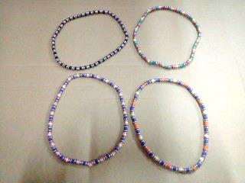
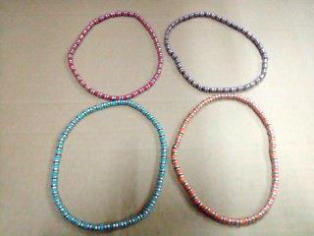

 |  |  | wood
 |  |  |  |  |  | pieces
 |  |  |  | black |  | 168
 |  |  |  | orange/beige |  | 312
 |  |  |  | orange |  | 564
 |  |  |  | green |  | 348
 |  |  |  | purple/pink |  | 348
 |  |  |  | red/pink/green |  | 336
 |  |  |  | red |  | 528
 |  |  |  | brown |  | 480
 |  |  |  |  |  | total | 3.084 | € 0,30 | € 925,20
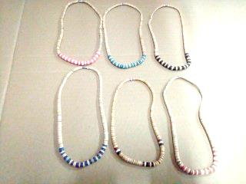 |  |  | wood |  |  | pieces
 |  |  |  | black |  | 696
 |  |  |  | navy |  | 600
 |  |  |  | red/rust |  | 780
 |  |  |  | turquoise |  | 600
 |  |  |  | pink |  | 804
 |  |  |  |  |  | total | 3.480 | € 0,30 | € 1.044,00
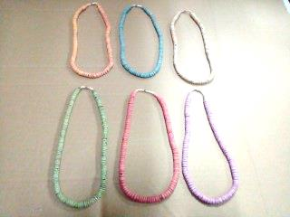 |  |  |  |  |  | pieces
 |  |  |  | beige |  | 300 |  | pcs.
 |  |  |  | fuchsia |  | 300 |  | pcs.
 |  |  |  | green |  | 588 |  | pcs.
 |  |  |  | purple |  | 588 |  | pcs.
 |  |  |  | salmon |  | 600 |  | pcs.
 |  |  |  | off white |  | 590 |  | pcs.
 |  |  |  | pink |  | 300 |  | pcs.
 |  |  |  | orange |  | 300 |  | pcs.
 |  |  |  | blue |  | 300 |  | pcs.
 |  |  |  | mix |  | 276 |  | pcs.
 |  |  |  |  |  | total | 4.142 | € 0,30 | € 1.242,60
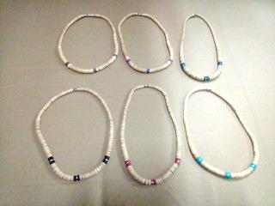 |  |  | wood |  |  | pieces
 |  |  |  | green |  | 408
 |  |  |  | turquoise |  | 492
 |  |  |  | black |  | 216
 |  |  |  | purple |  | 552
 |  |  |  | beige |  | 444
 |  |  |  | red |  | 552
 |  |  |  |  |  | total | 2.664 | € 0,30 | € 799,20
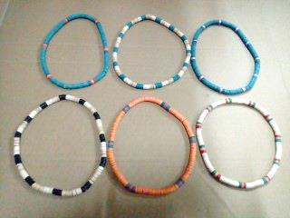
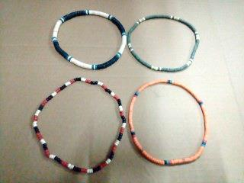

 |  |  |  |  |  | pieces
 |  |  |  | green |  | 600
 |  |  |  | beige/green/red |  | 468
 |  |  |  | brown |  | 1.116
 |  |  |  | turquoise/orange |  | 204
 |  |  |  | turquoise/grey |  | 120
 |  |  |  | orange |  | 204
 |  |  |  | mix |  | 192
 |  |  |  |  |  | total | 2.904 | € 0,30 | € 871,20
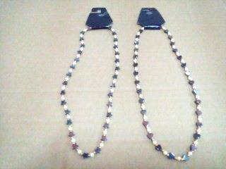

 |  |  |  |  |  |  | pieces
 |  |  |  |  |  |  | 468 | € 0,30 | € 140,40
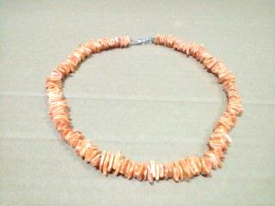

 |  |  |  |  |  |  | pieces
 |  |  |  |  |  |  | 72 | € 0,40 | € 28,80
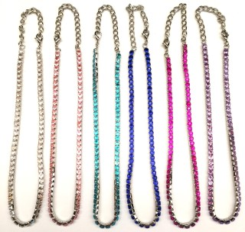

 |  |  | #H25
 |  |  |  |  |  |  | pieces
 |  |  |  |  |  |  | 2.076 | € 0,40 | € 830,40
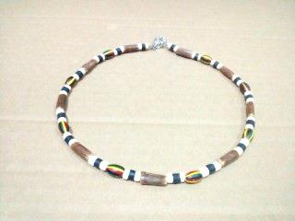
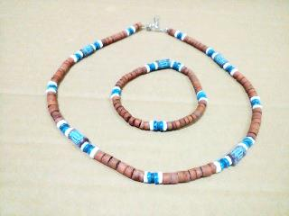

 |  |  |  |  |  | pieces
 |  |  |  | green |  | 372
 |  |  |  | blue |  | 60
 |  |  |  | orange |  | 480
 |  |  |  | brown/blue |  | 96
 |  |  |  | browwn/beige |  | 204
 |  |  |  |  |  | total | 1.212 | € 0,30 | € 363,60
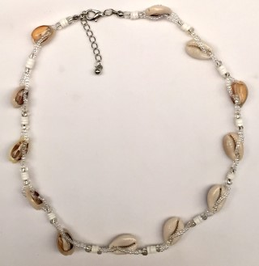

 |  |  |  |  |  |  | pieces
 |  |  |  |  |  |  | 142 | € 0,40 | € 56,80
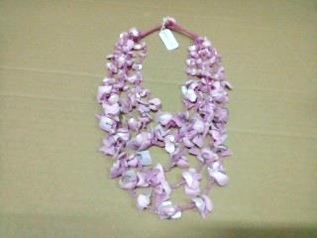  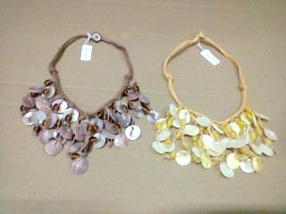 |  |  |  |  |  | pieces
 |  |  |  |  | naturel | 96
 |  |  |  |  | pink | 44
 |  |  |  |  | turquoise | 36
 |  |  |  |  | green | 48
 |  |  |  |  | yellow | 40
 |  |  |  |  | salmon | 48
 |  |  |  |  | brown | 108
 |  |  |  |  |  | total | 420 | € 0,65 | € 273,00
 |  |  |  |  |  | pieces
 |  |  |  |  | brown | 264
 |  |  |  |  | ivory | 252
 |  |  |  |  |  | total | 516 | € 0,65 | € 335,40
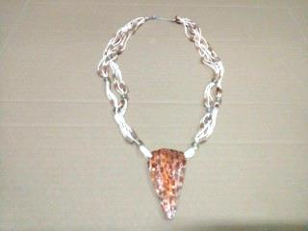
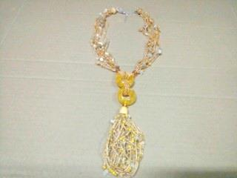

 |  |  |  |  |  |  | pieces
 |  |  |  |  |  |  | 432 | € 0,65 | € 280,80
 |  |  |  |  |  |  | pieces
 |  |  |  |  |  |  | 36 | € 0,65 | € 23,40
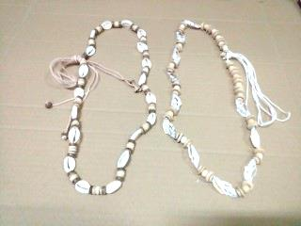

 |  |  |  |  |  |  | pieces
 |  |  |  |  |  |  | 78 | € 0,65 | € 50,70
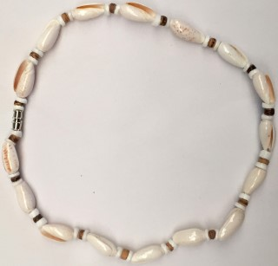
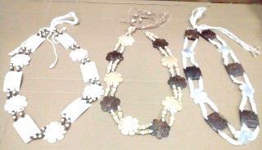

 |  |  |  |  |  |  | pieces
 |  |  |  |  |  |  | 370 | € 0,65 | € 240,50
 |  |  |  |  |  |  | pieces
 |  |  |  |  |  |  | 206 | € 0,65 | € 133,90
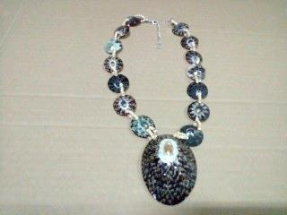
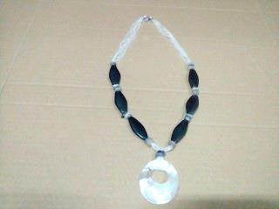
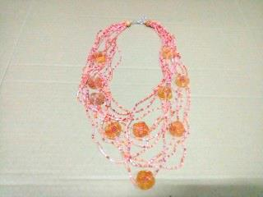

 |  |  |  |  |  |  | pieces
 |  |  |  |  |  |  | 72 | € 0,65 | € 46,80
 |  |  |  |  |  |  | pieces
 |  |  |  |  |  |  | 3 | 0,65 | € 1,95
 |  |  |  |  |  |  | pieces
 |  |  |  |  |  |  | 120 | € 0,65 | € 78,00
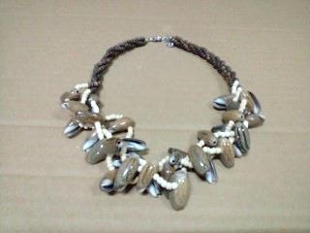

 |  |  |  |  |  |  | pieces
 |  |  |  |  |  |  | 168 | € 0,65 | € 109,20
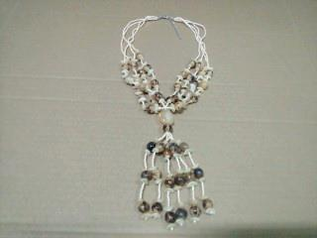

 |  |  |  |  |  |  | pieces
 |  |  |  |  |  |  | 36 | € 0,65 | € 23,40
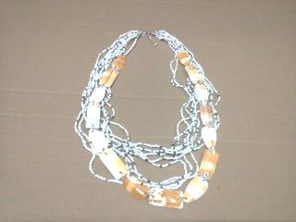
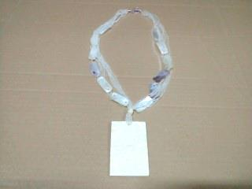

 |  |  |  |  |  |  | pieces
 |  |  |  |  |  |  | 24 | € 0,65 | € 15,60
 |  |  |  |  |  |  | pieces
 |  |  |  |  |  |  | 60 | € 0,50 | € 30,00
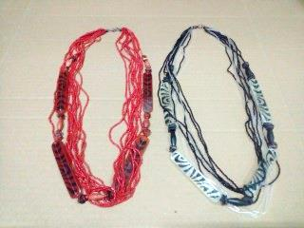
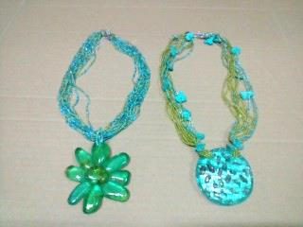

 |  |  |  |  |  | pieces
 |  |  |  |  | terra | 48
 |  |  |  |  | brown | 60
 |  |  |  |  |  | total | 108 | € 0,50 | € 54,00
 |  |  |  |  |  |  | pieces
 |  |  |  |  |  |  | 120 | € 0,50 | € 60,00
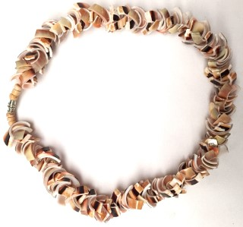

 |  |  |  |  |  |  | pieces
 |  |  |  |  |  |  | 144 | € 0,40 | € 57,60
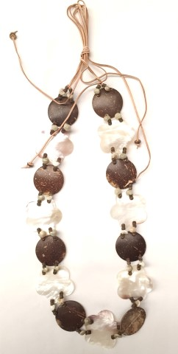

 |  |  |  |  |  |  | pieces
 |  |  |  |  |  |  | 24 | € 0,65 | € 15,60
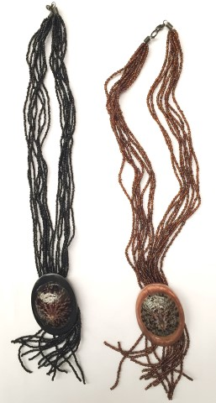
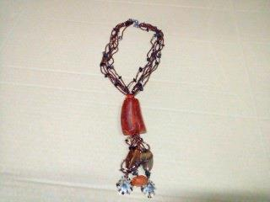

 |  |  |  |  |  | pieces
 |  |  |  |  | black | 36
 |  |  |  |  | brown | 36
 |  |  |  |  |  | total | 72 | € 0,50 | € 36,00
 |  |  |  |  |  |  | pieces
 |  |  |  |  |  |  | 24 | € 0,50 | € 12,00
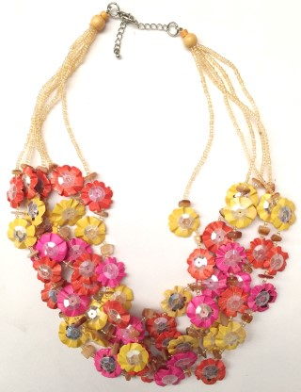
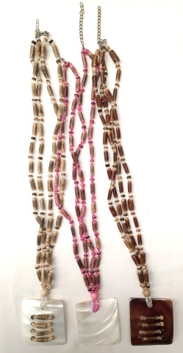
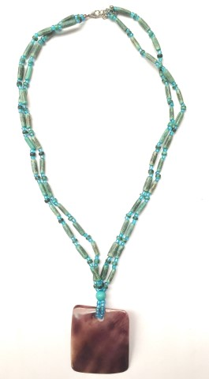

 |  |  |  |  |  | pieces
 |  |  |  |  | pink | 63
 |  |  |  |  | brown | 64
 |  |  |  |  | beige | 60
 |  |  |  |  |  | total | 187 | € 0,50 | € 93,50
 |  |  |  |  |  |  | pieces
 |  |  |  |  |  |  | 98 | € 0,50 | € 49,00
 |  |  |  |  |  |  | pieces
 |  |  |  |  |  |  | 36 | € 0,65 | € 23,40
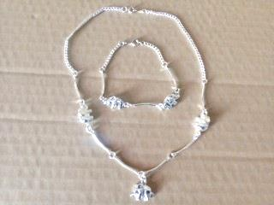
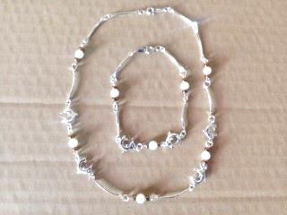

 |  |  |  | #H05
 |  |  |  |  |  |  | pieces
 |  |  |  | just necklace |  |  | 300 | € 0,65 | € 195,00
 |  |  |  | #H04
 |  |  |  |  |  |  | pieces
 |  |  |  | just necklace |  |  | 444 | € 0,65 | € 288,60
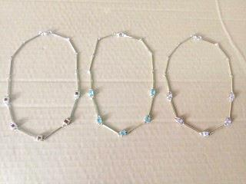
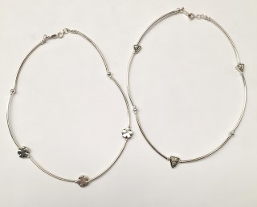

 |  |  |  | #H02 |  |  | pieces
 |  |  |  |  |  |  | 324 | € 0,65 | € 210,60
 |  |  |  |  |  |  | pieces
 |  |  |  | #H01 |  |  | 876 | € 0,65 | € 569,40
 |  |  |  |  |  |  | pieces
1 left carton mix styles |  |  |  |  |  |  | 139 | € 0,40 | € 55,60
 |  |  |  |  |  | total | 28.721 | pcs. | € 10.577,15

